General Camera Instructions

Setting up the camera

1. Set up the tripod at a reasonable height to image the patient. Make sure that the bubble on the level is in the center.
2. Set camera up on tripod by attaching it to the base plate using the screw to secure it so it does not move.
3. Turn on and log into laptop
4. Plug one end of the USB into the laptop and the other end into the camera
5. Open the **IR Flash** software on the laptop

* *You should be able to see a live image showing up
* Note: Once IR Flash is open DO NOT unplug the camera until you close the software!

1. Make sure the Palette is set **Gray Scale**
2. Make sure the **AGC box us unselected**
3. Adjust the **Min** and **Max** values based on the histogram to have the best contrast

* *Generally, min around 23 and max around 38

1. Focus the camera by moving the camera so that the distance between the patient and the front of the lens is between 14-21 inches

* Generally around 17 inches is a good focus

* Adjust based on the patient

* Only grab the camera body if you absolutely have to. After touching the camera body give it a minute or two to get stabilized again

10. After focusing, set the **Averaging** to 30

Note: If the live image ever starts to randomly get dark or have a weird gradient, go to **Camera** 🡪 **Image Touchup**. This would likely happen while the camera is warming up. Give the camera at least 15 minutes to warm up.

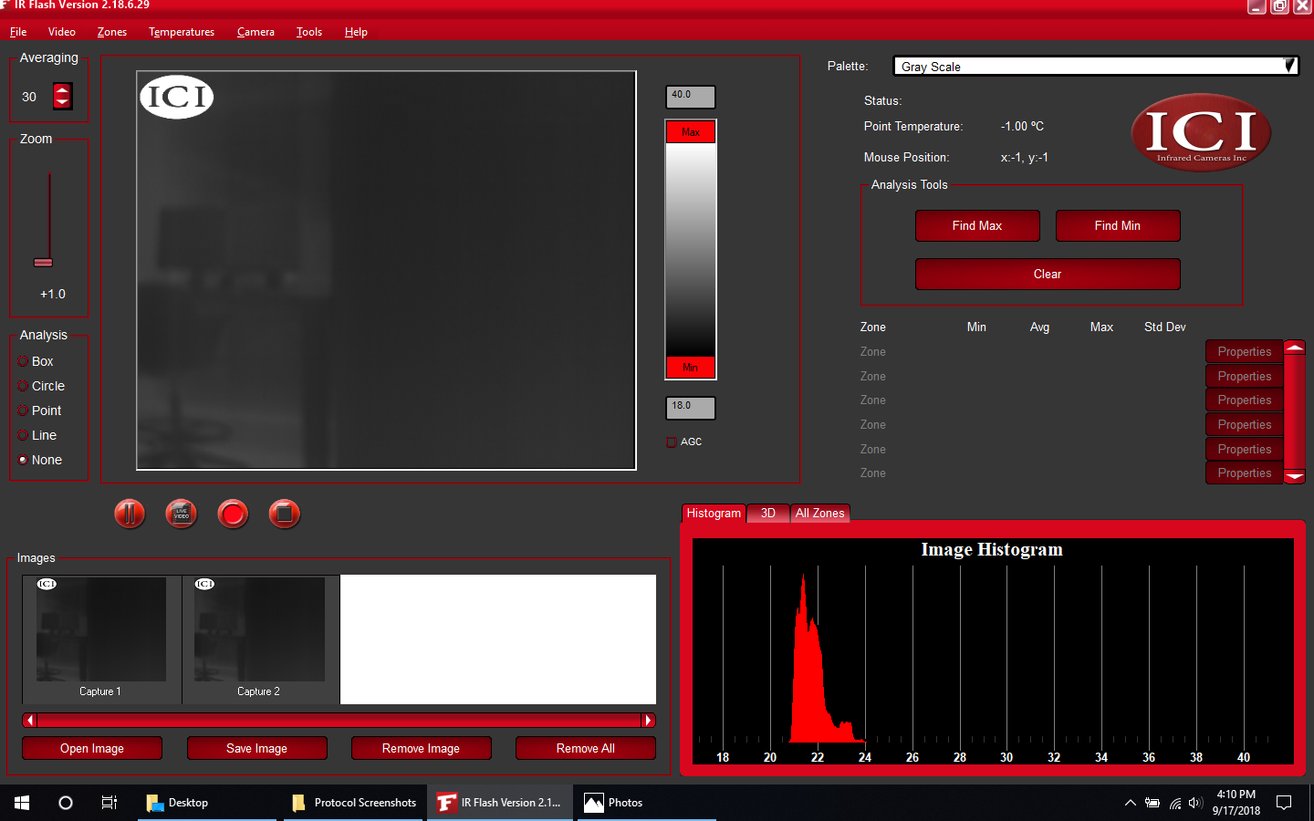

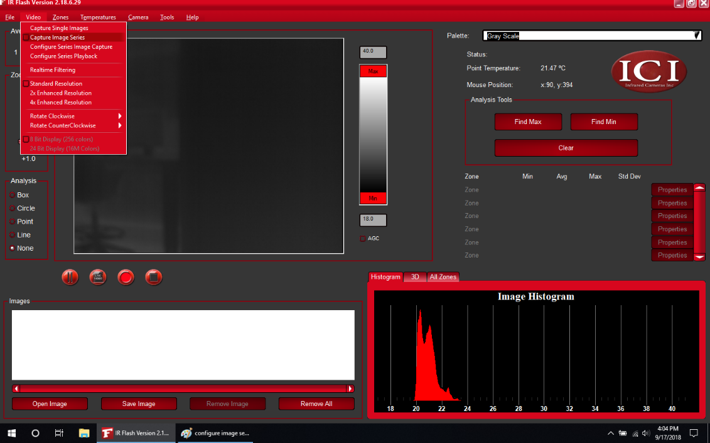Taking an Image Series

1. Select **Video** 🡪 **Configure Series Image Capture**
2. Set **Capture Type** to “**Capture for fixed time**”
3. Set **Time** to **0 hours 15 minutes 0 seconds**.
4. Change **Capture Rate** to **2 Per Minute**. Select OK

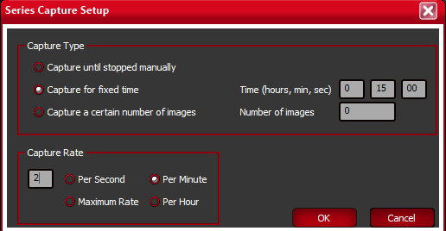

1. Select **Video** 🡪 **Capture Image Series**. Under the live image

* feed you should now see a red record button.

1. To begin the image series click the **red record** button:
2. To save all the images from the series, select

* File 🡪 Save All and make sure to save as a Raw 16 Bits

TIF File (*Note:* This will save all the images that are shown in the Image bar with numbers starting from NAME-0001 regardless of the capture number).

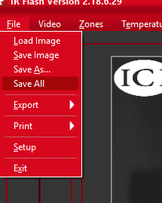

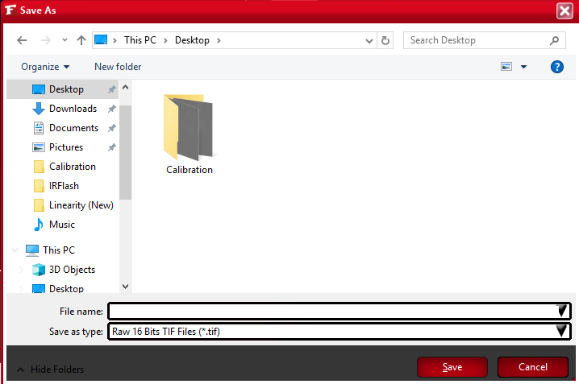

Taking a Single Image

1. Select **Video** 🡪 **Capture Single Images**
2. To take an image click the **camera button**. It will be added to the Image bar shown below.

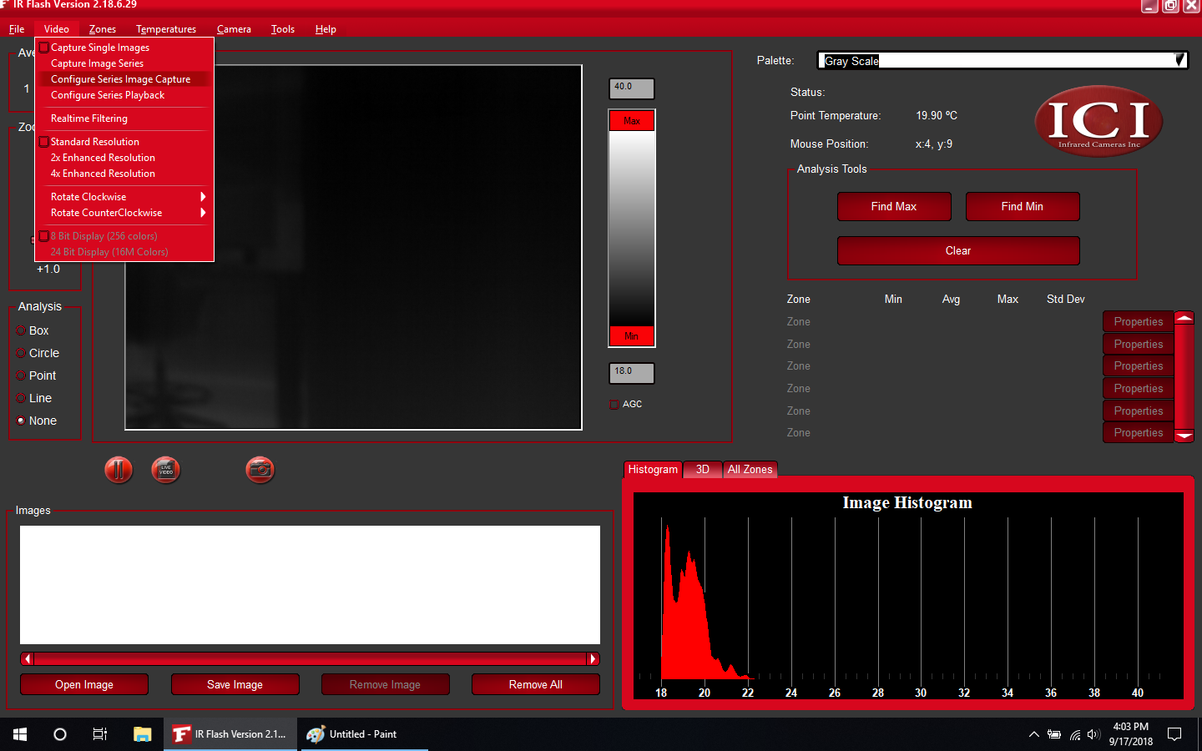

1. To save the image, select the image and click **Save Image**

